Walk-In Counselling
Wednesday – Friday
10:00am – 4:00pm

Counselling Services We Provide:

Abuse
Addictions
ADD/ADHD/ODD
Anger Management
Anxiety/Phobias
Behavioural Problems
Child and Youth
Depression
Grief
Individual/Couples/Family Counselling
Learning Disabilities
Personality and Career Assessments
Self-Esteem
Stress/PTSD

Offering professional, client-centered, and solution-focused services.
Our services are offered with a high degree of professionalism and confidentiality.
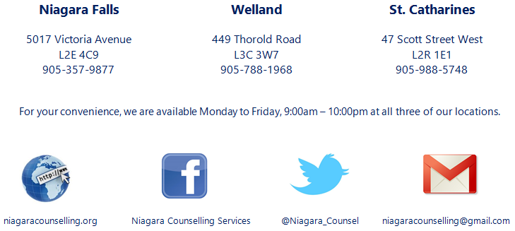
Our staff is equipped with the essential practical and theoretical knowledge ensuring client satisfaction. We aim to provide our clients with accessible and up-to-date resources, and opportunities for growth and achievement.

